|  |  |  |  |  |  |  |  |
| --- | --- | --- | --- | --- | --- | --- | --- |
| cs2 | cs1|cin | cs0 | Operation | Xi | Yi | Cin(i) | Cin(0) |
| 0 | 0 | 0 | Add | Ai | Bi | Cout(i-1) | 0 |
| 0 | 0 | 1 | Transfer A | Ai | 0 | Cout(i-1) | 0 |
| 0 | 1 | 0 | Add with carry | Ai | Bi | Cout(i-1) | 1 |
| 0 | 1 | 1 | Increment A | Ai | 0 | Cout(i-1) | 1 |

|  |  |  |  |  |
| --- | --- | --- | --- | --- |
| cs2 | cs1 | cs0 | operation | output |
| 1 | x | 0 | and | Ai and Bi |
| 1 | x | 1 | xor | Ai xor Bi |

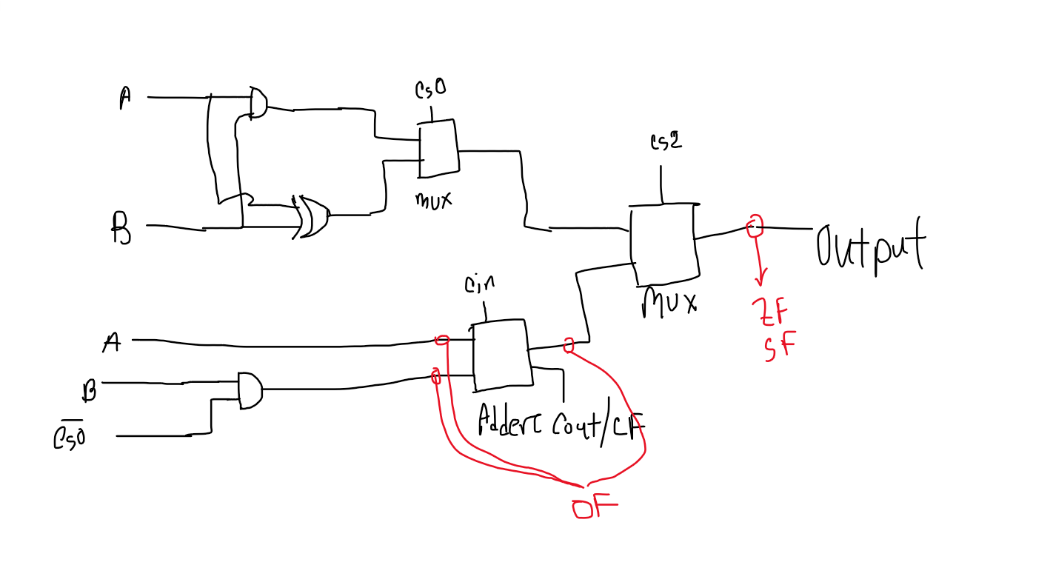

OF = XiYi ᄀFi  + ᄀXi ᄀYi Fi

CF = Cout(3)

SF = F3

ZF = nor Fi

|  |  |  |  |
| --- | --- | --- | --- |
| gate | gate Count | Ic count | reason |
| 2 bit And | 4 + 4 + 4 | 7408 quad 2 input and * 3 | Ai and Bi + Bi and not cs0+OF |
| 2 bit Or | 1 | ~~Can done with nor + not~~  7432 quad 2 input or * 1 | OF+ |
| 1 bit not | 1 +3 | 7404 hex inverter * 1 | Not cs0 + OF |
| 4 bit nor | 1 | [~~744002~~](https://web.archive.org/web/20170221111335/http://www.ti.com/lit/ds/symlink/cd74hc4002.pdf) ~~dual 4 input nor * 1~~  Can done with 3 or +1 not | ZF |
| 2 to 1 mux | 4+4 | 74157 quad 2 to 1 mux * 2 | Cs0 + cs2 |
| 2 bit xor | 4 | 7486 quad 2 input xor * 2 | Ai xor Bi |
| 4 bit adder | 1 | 7483 4-bit binary full adder * 1 | adder |
|  |  |  |  |